**Global Challenges for Humanity**

- excerpt from [2009 State of the Future](http://www.millennium-project.org/millennium/sof2009.html) -

Top of Form

Bottom of Form

*The 15 Global Challenges updated annually continue to be* ***the*** *best introduction by far to the key issues of the early 21st century.*  
                            -- Michael Marien, editor, *Future Survey*

The 15 Global Challenges provide a framework to assess the global and local prospects for humanity. Their description, with a range of views and actions to addressed each, enriched with regional views and progress assessments are updated each year since 1996 and published in the annual [***State of the Future*.**](http://www.millennium-project.org/millennium/issues.html)The short description of the challenges appears in the print version of the report, while a detailed, more complex one is on the CD that accompanies the report. The detailed version of the Global Challenges available in the CD’s Chapter 1 are totaling over 1,300 pages. For each Challenge, there is a more comprehensive overview, alternative views or additional comments from participants on the overview, regional perspectives and relevant information from recent literature, a set of actions with a range of views from interviews with decisionmakers to address the challenge, additional actions and views on those actions, and suggested indicators to measure progress or lack thereof.

The Challenges are interdependent: an improvement in one makes it easier to address others; deterioration in one makes it harder to address others. Arguing whether one is more important than another is like arguing that the human nervous system is more important than the respiratory system. These Challenges are transnational in nature and trans-institutional in solution. They cannot be addressed by any government or institution acting alone. They require collaborative action among governments, international organizations, corporations, universities, NGOs, and creative individuals. Although listed in sequence, Challenge 1 on sustainable development and climate change is no more or less important than Challenge 15 on global ethics. There is greater consensus about the global situation as expressed in these Challenges and the actions to address them than is evident in the news media.

We are welcoming input on the description and update of the challenges. Those will help improve the next edition of the [*State of the Future*](http://www.millennium-project.org/millennium/issues.html) report.

A short (about 2 minutes) video versions of each of the 15 Global Challenges is available on YouTube [http://www.youtube.com/view_play_list?p=2C7D2B78000F1C2D](http://www.youtube.com/view_play_list?p=2C7D2B78000F1C2D&session=NJ0zouHean8RkLRRx4ZXGo6ad_WGXWV9UyFjjchhQ3hsqOJZoaODVx11MkXoBeJWA4r-ck6gOTZgtG6bndE8hEIb6HakMaRdC80PeK8WbkjV08hgE4vv8cGNi2wc4syWad4I4qwMWm--kA4uo9EUVKsu2f4W3kJCoD1n45vocIyMq0YvLjBJyj9JS78Lc49KmMO16VdvDRndq9LoHlo__0HyfswIfrgJtHAtryHI4S4vVxRWyLvBCRqDWOZT3US_S-6-FMqpHPyNJSO3G7kNpYUt23sWrNC1wReeauRDUlxYmkrjtz1klFZvDla6Mb1I)

**15 Global Challenges**

[1. How can sustainable development be achieved for all while addressing global climate change?](http://www.millennium-project.org/millennium/Global_Challenges/chall-01.html)

[2. How can everyone have sufficient clean water without conflict?](http://www.millennium-project.org/millennium/Global_Challenges/chall-02.html)

[3. How can population growth and resources be brought into balance?](http://www.millennium-project.org/millennium/Global_Challenges/chall-03.html)

[4. How can genuine democracy emerge from authoritarian regimes?](http://www.millennium-project.org/millennium/Global_Challenges/chall-04.html)

[5. How can policymaking be made more sensitive to global long-term perspectives?](http://www.millennium-project.org/millennium/Global_Challenges/chall-05.html)

[6. How can the global convergence of information and communications technologies work for everyone?](http://www.millennium-project.org/millennium/Global_Challenges/chall-06.html)

[7. How can ethical market economies be encouraged to help reduce the gap between rich and poor?](http://www.millennium-project.org/millennium/Global_Challenges/chall-07.html)

[8. How can the threat of new and reemerging diseases and immune micro-organisms be reduced?](http://www.millennium-project.org/millennium/Global_Challenges/chall-08.html)

[9. How can the capacity to decide be improved as the nature of work and institutions change?](http://www.millennium-project.org/millennium/Global_Challenges/chall-09.html)

[10. How can shared values and new security strategies reduce ethnic conflicts, terrorism, and the use of weapons of mass destruction?](http://www.millennium-project.org/millennium/Global_Challenges/chall-10.html)

[11. How can the changing status of women help improve the human condition?](http://www.millennium-project.org/millennium/Global_Challenges/chall-11.html)

[12. How can transnational organized crime networks be stopped from becoming more powerful and sophisticated global enterprises?](http://www.millennium-project.org/millennium/Global_Challenges/chall-12.html)

[13. How can growing energy demands be met safely and efficiently?](http://www.millennium-project.org/millennium/Global_Challenges/chall-13.html)

[14. How can scientific and technological breakthroughs be accelerated to improve the human condition?](http://www.millennium-project.org/millennium/Global_Challenges/chall-14.html)

[15. How can ethical considerations become more routinely incorporated into global decisions?](http://www.millennium-project.org/millennium/Global_Challenges/chall-15.html)

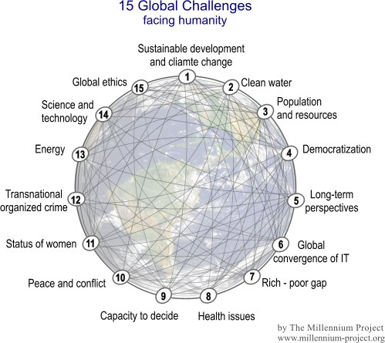

**Background**

Both print and CD versions of the15 Global Challenges are the cumulative and distilled range of views from over 2,700 participants. The list of challenges is the result of the distillation, merger, and update of the [15 Global Issues](http://www.millennium-project.org/millennium/isandop.html) presented in the *1997 State of the Future* and the [15 Global Opportunities](http://www.millennium-project.org/millennium/isandop.html) from the 1998 edition, and their associated actions. These Global Challenges are interdependent and present what we believe are the crucial questions for policy action now and in the next decade. Making wise and timely decisions about these challenges will set the course of global development and societal achievements in the years immediately ahead.

The international Delphi panels were selected by Millennium Project [Nodes](http://www.millennium-project.org/millennium/nodes.html) around the world for their knowledge and creativity as futurists, scholars, business planners, scientists, and decisionmakers who work for governments, private corporations, NGOs, universities, and international organizations. Full details of the questionnaires and interview protocols that have been used since 1996 to generate both the short and more detailed treatments of these Challenges are available at [www.millennium-project.org/millennium/lookout.html](http://www.millennium-project.org/millennium/lookout.html).